**Frequency Distributions**

1. Fill out the rest of this simple distribution table by calculating the relative frequency, cumulative frequency, and cumulative percent. Round final answers to the 2nd decimal place.

|  |  |  |  |  |
| --- | --- | --- | --- | --- |
| ***X*** | ***f*** | ***rf*** | ***cf*** | ***c%*** |
| 10 | 5 | .08 | 60 | 100% |
| 9 | 0 | .00 | 55 | 92% |
| 8 | 10 | .17 | 55 | 92% |
| 7 | 20 | .33 | 45 | 75% |
| 6 | 25 | .42 | 25 | 42% |

*N* = 60

1. Using the data set given below. Create a simple distribution table by calculating the relative frequency, cumulative frequency, and cumulative percent. Round final answers to the 2nd decimal place.

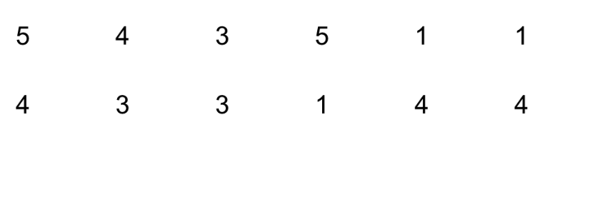

|  |  |  |  |  |
| --- | --- | --- | --- | --- |
| ***X*** | ***f*** | ***rf*** | ***cf*** | ***c%*** |
| 5 | 2 | .17 | 12 | 100% |
| 4 | 4 | .33 | 10 | 83% |
| 3 | 3 | .25 | 6 | 50% |
| 2 | 0 | .00 | 3 | 25% |
| 1 | 3 | .25 | 3 | 25% |

1. A police radar unit measured the speed of 25 cars on Elm Street. The resulting speeds were: 29, 23, 30, 30, 27, 24, 30, 25, 23, 28, 25, 24, 28, 30, 23, 30, 27, 25, 29, 24, 23, 26, 30, 28, and 25.
   1. Create a simple distribution table by calculating the relative frequency, cumulative frequency, and cumulative percent. Round final answers to the 2nd decimal place.
   2. Draw a histogram to represent these data.

|  |  |  |  |  |
| --- | --- | --- | --- | --- |
| ***X*** | ***f*** | ***rf*** | ***cf*** | ***c%*** |
| 30 | 6 | .24 | 25 | 100% |
| 29 | 2 | .08 | 19 | 76% |
| 28 | 3 | .12 | 17 | 68% |
| 27 | 2 | .08 | 14 | 56% |
| 26 | 1 | .04 | 12 | 48% |
| 25 | 4 | .16 | 11 | 44% |
| 24 | 3 | .12 | 7 | 28% |
| 23 | 4 | .16 | 4 | 16% |

Speed

23 24 25 26 27 28 29 30

Frequency